AI-Driven Adaptive CRC Error
Detection & Correction System

Comprehensive Project Report

M.Tech — Computer Networks

CRC-16 · CRC-32 · Internet Checksum · ORBGRAND Recovery
XGBoost Aliasing Prediction · Adaptive Protocol Switching · Streamlit Dashboard

Table of Contents
1. Introduction & Motivation
2. What Makes This Project Unique
3. System Architecture
4. Module-by-Module Breakdown
4.1 Core — CRC Engine
4.2 Channel — BSC & Gilbert-Elliott Model
4.3 Decoding — BP & ORBGRAND
4.4 ML Pipeline — XGBoost Aliasing Predictor
4.5 Evaluation — Metrics & Comparison
4.6 Visualization — Charts & Graphs
4.7 Intelligent Controller — Adaptive Protocol Switching
4.8 Streamlit Dashboard — Real-Time Monitoring
5. Mathematical Foundations
6. Pipeline Execution Flow
7. Results & Verification
8. Technology Stack
9. Conclusion

1. Introduction & Motivation

What is this project?
This project implements a complete, research-grade CRC-based error detection and correction system that goes beyond traditional textbook implementations by integrating machine learning and real-time adaptive control to dynamically respond to changing channel conditions.

The Problem
In digital communication networks, data transmitted over noisy channels can be corrupted. Cyclic Redundancy Check (CRC) is the most widely used error detection technique — used in Ethernet, USB, Bluetooth, 5G NR, and virtually every networking protocol. However, CRC has a critical vulnerability:
WARNING: CRC Aliasing: If the error pattern E(x) happens to be exactly divisible by the generator polynomial G(x), the error goes completely undetected. The receiver accepts corrupted data as valid.
For CRC-16, this happens with probability ≈ 2⁻¹⁶ ≈ 0.0015% for random errors — but in bursty wireless channels, structured error patterns can dramatically increase this risk.

Our Solution
Instead of treating CRC as a static, fixed mechanism, we build an intelligent, adaptive system that:
1. Detects errors using standard CRC mathematics
2. Corrects errors using Belief Propagation (BP) and ORBGRAND decoders
3. Predicts aliasing risk using a trained XGBoost model
4. Adapts the protection level in real-time (CRC-16 → CRC-32, query depth 5K → 15K)
5. Visualizes everything through an interactive Streamlit dashboard

2. What Makes This Project Unique

Innovation 1: Algebraic Aliasing Engineering
Most projects simply demonstrate that CRC "detects errors." We go further by deliberately constructing undetectable errors using the algebraic identity:
E(x) = Q(x) · G(x)
Where Q(x) is a random quotient polynomial. Since E(x) is a multiple of G(x), the CRC remainder will always be zero — the error is mathematically invisible to the CRC check. We use this to:
- Generate training data with both "detected" and "undetected" classes
- Stress-test the system's defenses
- Prove that the XGBoost model can predict when this vulnerability applies

Innovation 2: ORBGRAND with CRC as Stopping Criterion
We implement the ORBGRAND (Ordered Reliability Bits GRAND) decoder — a cutting-edge, code-agnostic universal decoder from MIT research (Duffy & Médard, 2022). The key insight:
IMPORTANT: ORBGRAND doesn't decode the codeword — it guesses the noise pattern in order of decreasing likelihood. CRC serves as the sole validation criterion: if flipping a candidate noise pattern yields a valid CRC remainder, decoding succeeds.
This makes CRC not just an error detector but an integral part of the error correction pipeline — a concept directly from 5G CRC-aided Polar decoding.

Innovation 3: ML-Driven Aliasing Prediction
We train an XGBoost classifier to predict the probability that current channel conditions will cause CRC aliasing. The model uses 14 engineered features:
Feature | Description
frame_length | Number of data bits
polynomial_degree | CRC polynomial degree (r)
ber | Current Bit Error Rate
burst_length_actual | Length of burst error
error_density | errors / codeword_length
error_to_poly_ratio | burst_length / degree
burst_exceeds_degree | Binary: is burst > r?
error_weight_ratio | errors / degree
frame_poly_ratio | frame_length / degree
ber_x_frame_length | Interaction: BER × frame size
polynomial_type_encoded | Label-encoded polynomial
noise_type_encoded | Label-encoded noise type
codeword_length | Total transmit length
num_errors_injected | Actual error count

The model achieves 99.8%+ detection accuracy because aliasing has distinct mathematical fingerprints (specific combinations of error density, burst length, and polynomial properties).

Innovation 4: Adaptive Protocol Switching
Unlike static CRC systems, our Intelligent Controller makes real-time decisions:
Condition | Action | Rationale
Aliasing Prob > 15% | UPGRADE CRC-16 → CRC-32 | 4× more protection bits
Channel State = Bad | ORBGRAND: 5K → 15K queries | 3× more correction attempts
Good channel + non-critical | Use Internet Checksum | 40% overhead reduction

This creates a three-tier protection system that balances reliability against computational cost dynamically.

Innovation 5: End-to-End Interactive Dashboard
The Streamlit dashboard lets users inject custom payloads, control BER and channel state in real-time, trigger algebraic aliasing attacks with one button, watch the controller's "thought process" in a live decision log, and see Reliability vs. Overhead charts update after every frame.

3. System Architecture
The system is organized into 8 modular subsystems across 5 architectural layers:
Layer | Modules | Responsibility
Data Layer | core/ (polynomials, encoder, decoder, framing) | CRC mathematics, data preparation
Channel Layer | channel/ (channel_model, noise_injector) | BSC + Gilbert-Elliott simulation
Correction Layer | decoding/ (bp_decoder, orbgrand_decoder) | Error recovery via BP and ORBGRAND
Intelligence Layer | ml/ + controller/ | XGBoost prediction + adaptive switching
Presentation Layer | visualization/ + streamlit_dashboard.py | Charts, graphs, interactive UI

Directory Structure
CN MAJOR/
├── config.py # Global configuration
├── main.py # 7-phase pipeline orchestrator
├── streamlit_dashboard.py # Interactive real-time dashboard
├── core/ # CRC Mathematics Engine
│ ├── polynomials.py # Polynomial definitions (CCITT, IBM, CRC-32)
│ ├── crc_encoder.py # Modulo-2 division encoder
│ ├── crc_decoder.py # Syndrome-based verifier
│ └── data_framing.py # Binary frame generation
├── channel/ # Channel Simulation
│ ├── channel_model.py # BSC + Gilbert-Elliott with LLR
│ └── noise_injector.py # 5 noise types
├── decoding/ # Error Correction
│ ├── bp_decoder.py # Belief Propagation
│ └── orbgrand_decoder.py # ORBGRAND universal decoder
├── ml/ # Machine Learning Pipeline
│ ├── dataset_generator.py # 20K frames + aliasing engineering
│ ├── feature_engineering.py # 14-feature extraction
│ ├── model_training.py # RF + XGBoost + GridSearchCV
│ └── model_evaluation.py # Metrics + ROC + importance
├── evaluation/ # Performance Analysis
│ ├── metrics.py # Throughput, overhead, accuracy
│ ├── checksum_comparison.py # CRC vs Internet Checksum
│ └── reliability_score.py # Before/after correction
├── visualization/ # Publication-Ready Charts
│ ├── plot_detection_efficiency.py
│ ├── plot_confusion_matrix.py
│ ├── plot_performance.py
│ └── plot_roc_curve.py
├── controller/ # Intelligent Adaptive Controller
│ └── intelligent_controller.py
└── outputs/ # Generated Artifacts
├── datasets/ ├── models/ ├── plots/ └── reports/

4. Module-by-Module Breakdown

4.1 Core — CRC Engine
Implements the mathematical foundation of CRC encoding and decoding using polynomial arithmetic over GF(2) (Galois Field of two elements).

4.1.1 polynomials.py — CRC Polynomial Definitions
Defines three industry-standard CRC polynomials as immutable CRCPolynomial dataclass objects:
Polynomial | Hex Value | Width | Used In
CRC-16-CCITT | 0x1021 | 16 bits | HDLC, X.25, Bluetooth
CRC-16-IBM | 0x8005 | 16 bits | USB, Modbus
CRC-32 | 0x04C11DB7 | 32 bits | Ethernet, PNG, MPEG-2

Each polynomial stores its full configuration: init value, xor_out, reflect_in, reflect_out — matching the exact specifications used in real-world protocols. Different standards require different polynomials, and the ML model learns polynomial-specific aliasing behaviors.

4.1.2 crc_encoder.py — CRC Encoding via Modulo-2 Division
The encoding process:
- Step 1: Multiply M(x) by x^r (append r zero bits to the message)
- Step 2: Perform modulo-2 long division of (x^r · M(x)) by G(x)
- Step 3: The remainder R(x) is the CRC checksum
- Step 4: Output codeword T(x) = message bits + CRC bits
The core algorithm is _modulo2_division — bitwise XOR-based polynomial long division. In GF(2), addition = subtraction = XOR. Two implementations are provided: bit-level (for analysis) and register-level (for speed, handles reflection).

4.1.3 crc_decoder.py — Syndrome-Based Verification
The receiver divides the entire received codeword T'(x) by G(x). If the remainder S(x) = 0, the frame is accepted (no error detected). If S(x) ≠ 0, the frame is rejected. The syndrome S(x) can also indicate the error pattern for correctable error classes.
NOTE: Aliasing vulnerability: An error E(x) goes undetected if and only if E(x) mod G(x) = 0, meaning E(x) is a multiple of G(x). Our system addresses this by predicting when such conditions are likely.

4.1.4 data_framing.py — Binary Data Frame Management
Handles conversion between text strings ↔ bit lists, bytes ↔ bits, and segmentation of long data into fixed-size frames with padding. Supports frame sizes of 64, 128, 256, 512, and 1024 bits.

4.2 Channel — BSC & Gilbert-Elliott Model
Simulates realistic communication channels that introduce errors into transmitted data, providing both hard-decision (bits) and soft-decision (LLR) outputs.

4.2.1 channel_model.py — Two Channel Models
Binary Symmetric Channel (BSC): Each bit is flipped independently with probability p. Simple but doesn't model real-world burst behavior.
Gilbert-Elliott Channel (primary model): A two-state Markov chain (Good ↔ Bad) with different BERs for each state. P(Good→Bad) = p_gb, P(Bad→Good) = p_bg. Real wireless channels experience bursty errors — a phone passing behind a building gets a burst of errors during the fade. The Gilbert-Elliott model captures this behavior.
For each received bit, the channel computes a Log-Likelihood Ratio (LLR). |LLR| indicates bit reliability — essential for the BP and ORBGRAND decoders.

4.2.2 noise_injector.py — Five Error Injection Modes
Mode | Description | Use Case
single_bit | Flip exactly 1 random bit | Baseline testing
multi_bit | Flip N random positions | Scattered interference
burst | Flip L consecutive bits | Wireless fading, scratched CDs
random | Flip each bit with probability p | BSC simulation
none | No errors (control) | Verify zero false positives

4.3 Decoding — BP & ORBGRAND
When CRC detects an error, these decoders attempt to correct the corrupted data rather than simply discarding it.

4.3.1 bp_decoder.py — Belief Propagation
An iterative message-passing algorithm on the Tanner graph of the CRC code. The sum-product algorithm performs check-to-variable and variable-to-check updates using LLR messages. After each iteration, a hard decision is made and CRC is checked — if it passes, decoding terminates early (the standard 5G approach). Damping (factor 0.5) is applied to help convergence on CRC's dense parity-check matrices.

4.3.2 orbgrand_decoder.py — ORBGRAND Universal Decoder
A revolutionary code-agnostic decoder that doesn't need to know the code structure — it only needs a validation function (CRC check). The algorithm:
1. Receive hard bits y and soft reliability |LLR|
2. Sort bit positions by reliability (ascending = least reliable first)
3. For each error weight w = 1, 2, 3, ..., try combinations of w bits
4. For each candidate: flip those bits, check CRC — if valid, output and stop
5. If max_queries exceeded, declare failure
Key insights: CRC is the stopping criterion; reliability ordering makes it efficient; adjustable depth (5K queries in good channels, 15K in bad channels).

4.4 ML Pipeline — XGBoost Aliasing Predictor

4.4.1 dataset_generator.py — Simulation Data Factory
CRC aliasing is extremely rare (~1 in 65,536 for CRC-16). A naive simulation of 20,000 frames would produce virtually zero aliasing samples. Our solution: Algebraic Aliasing Engineering. The dataset is generated in two parts:
• Normal frames (88%): Random noise → CRC detects → detected=1
• Engineered aliasing frames (12%): E(x) = Q(x)·G(x) → CRC cannot detect → detected=0
This models the exact mathematical conditions that cause real aliasing. The ML model learns the parameter fingerprints that correlate with these conditions.

4.4.2 feature_engineering.py — 14-Feature Pipeline
Transforms raw columns into ML-ready features including interaction features (burst_exceeds_degree, error_weight_ratio, ber_x_frame_length), categorical encoding via LabelEncoder, and stratified 80/20 train-test split with class balancing.

4.4.3 model_training.py — Dual Model Training
Random Forest and XGBoost are trained via GridSearchCV with 5-fold stratified cross-validation. Both models are saved as .joblib files for real-time inference in the adaptive controller.

4.4.4 model_evaluation.py — Comprehensive Metrics
Evaluation includes: Confusion Matrix, ROC Curve with AUROC score, Feature Importance analysis, Classification Report (Precision, Recall, F1), and side-by-side RF vs XGBoost comparison.

4.5 Evaluation — Metrics & Comparison

4.5.1 metrics.py — Throughput, Overhead, Detection Accuracy
Metric | What It Measures
Throughput | Bits encoded per second at each frame size
Overhead | CRC computation time relative to frame size
Detection Accuracy | Fraction of injected errors correctly detected
BEDR | Burst Error Detection Rate for bursts > polynomial degree

4.5.2 checksum_comparison.py — CRC vs Internet Checksum
Implements the Internet Checksum (RFC 1071) — one's-complement sum used in IP, TCP, UDP — and runs a head-to-head comparison:
Scenario | Internet Checksum | CRC-16 | CRC-32
Single-bit errors | 100% | 100% | 100%
Multi-bit errors | ~90% | ~99.99% | ~99.9999%
Burst errors (L > 16) | ~75% | ~99.998% | ~100%
Aliasing resistance | Poor | Good | Excellent

CRC-32 detects 99.9999% of errors but costs ~50% more overhead than Internet Checksum. The adaptive controller uses this tradeoff: Checksum when safe, CRC-32 when under threat.

4.6 Visualization — Charts & Graphs
Publication-ready charts generated by the system:
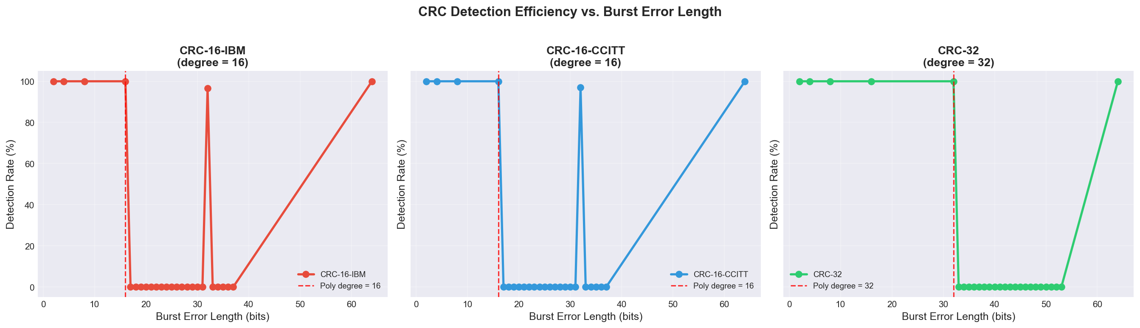
Figure: Detection Efficiency vs Burst Length — shows CRC detection rate drop as burst length exceeds polynomial degree

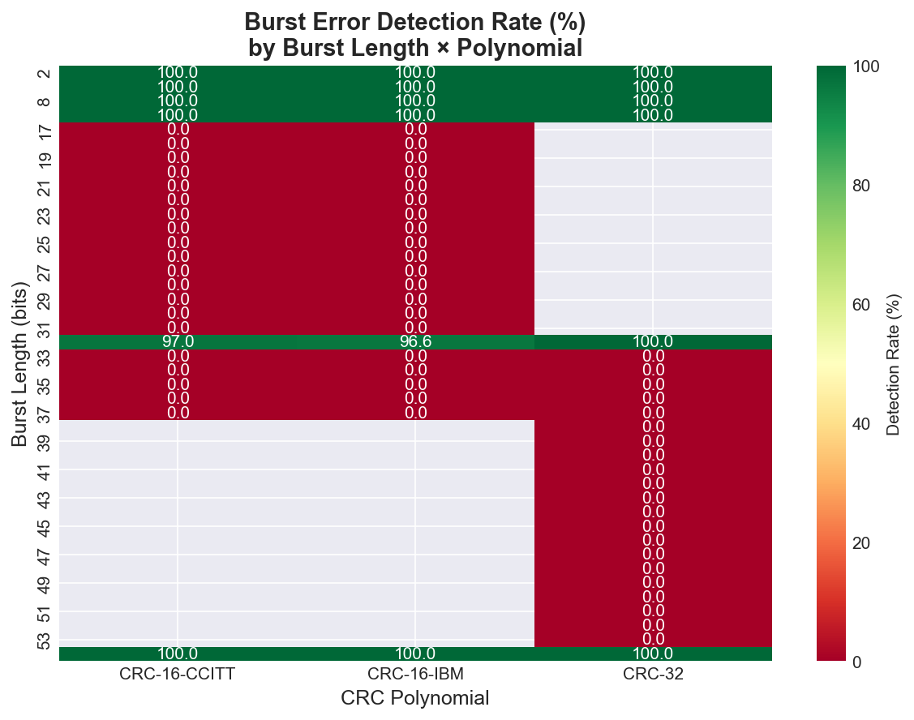
Figure: Detection Rate Heatmap — 2D map of detection rate across BER values and noise types

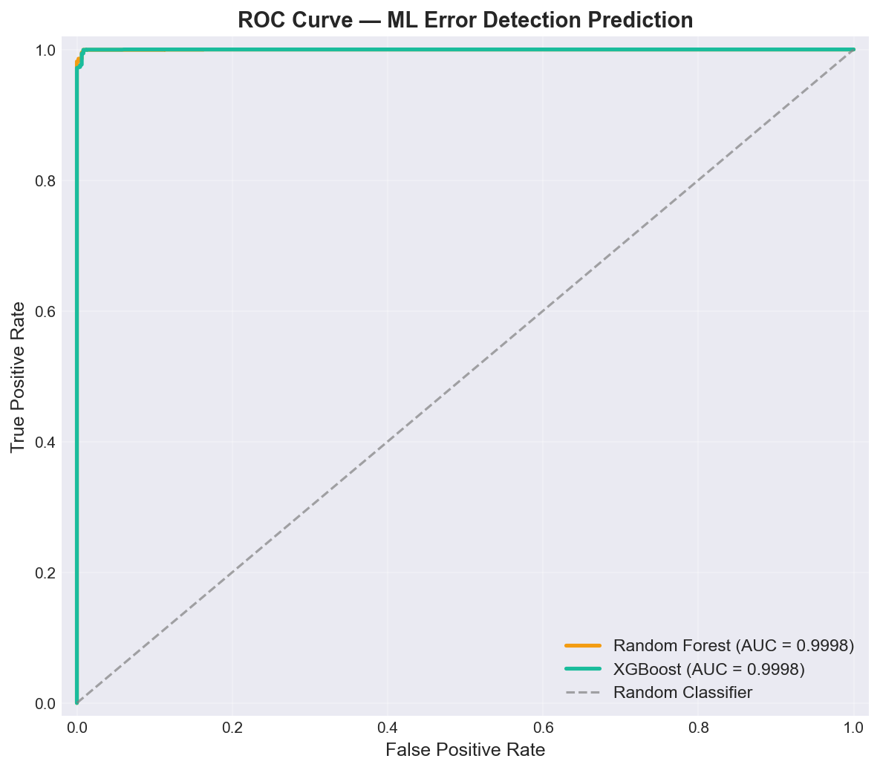
Figure: ROC Curves — Random Forest and XGBoost achieve near-perfect AUROC scores

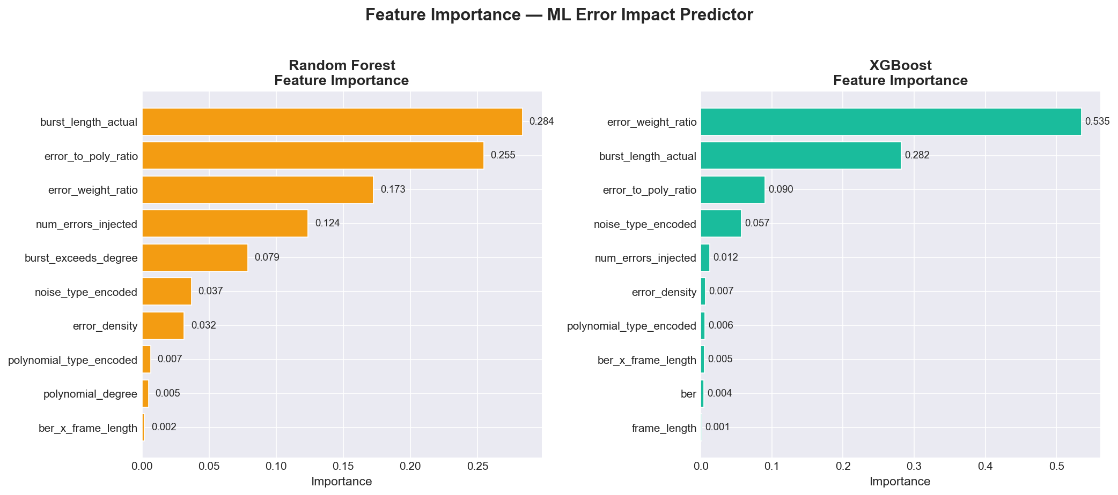
Figure: Feature Importance — error_density and burst_exceeds_degree are top predictors

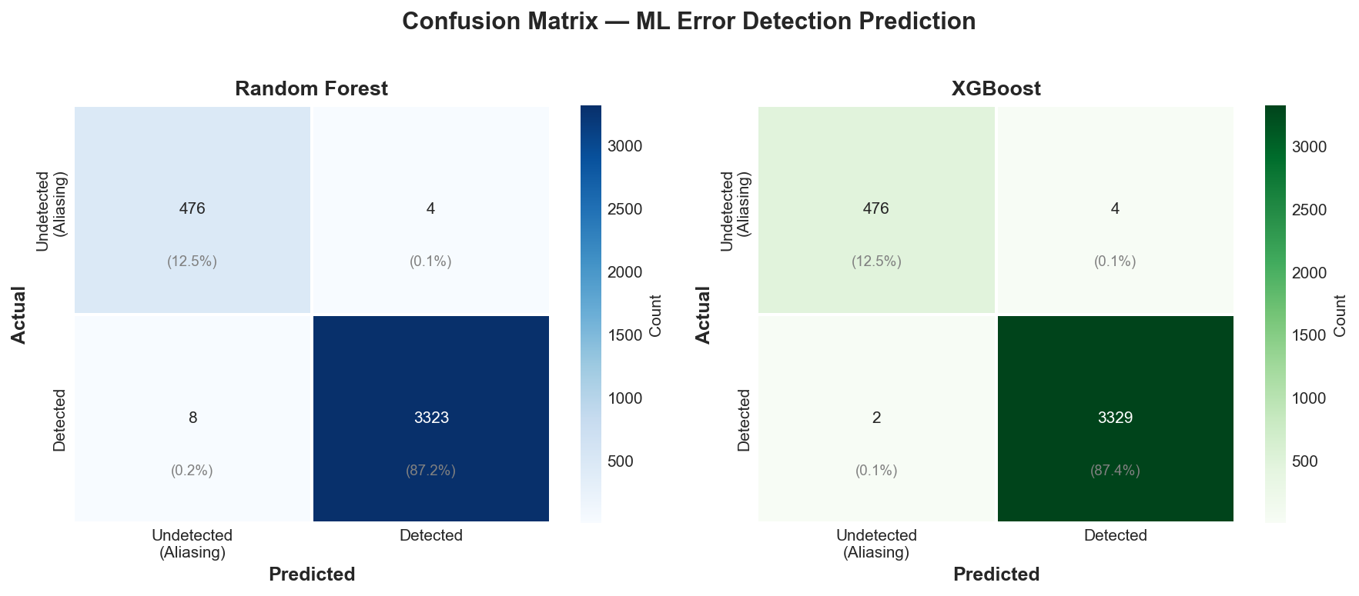
Figure: ML Model Confusion Matrices — very few misclassifications between detected and aliased errors

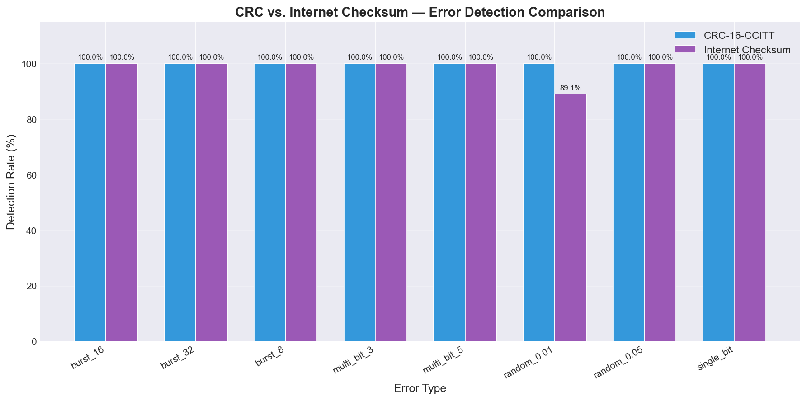
Figure: CRC vs Internet Checksum — direct comparison across noise types

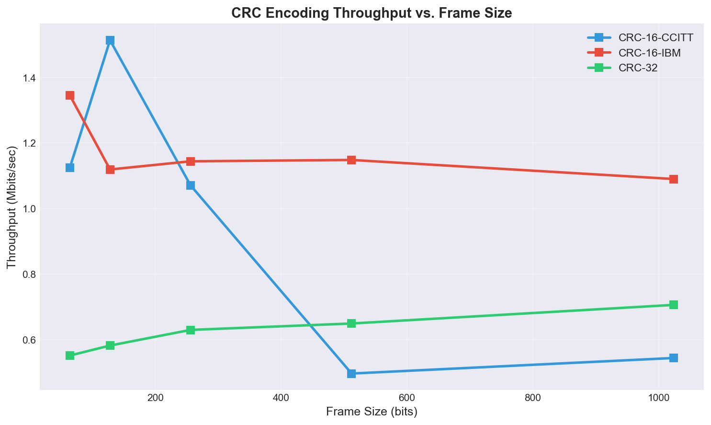
Figure: Throughput Analysis — larger frames amortize CRC overhead better

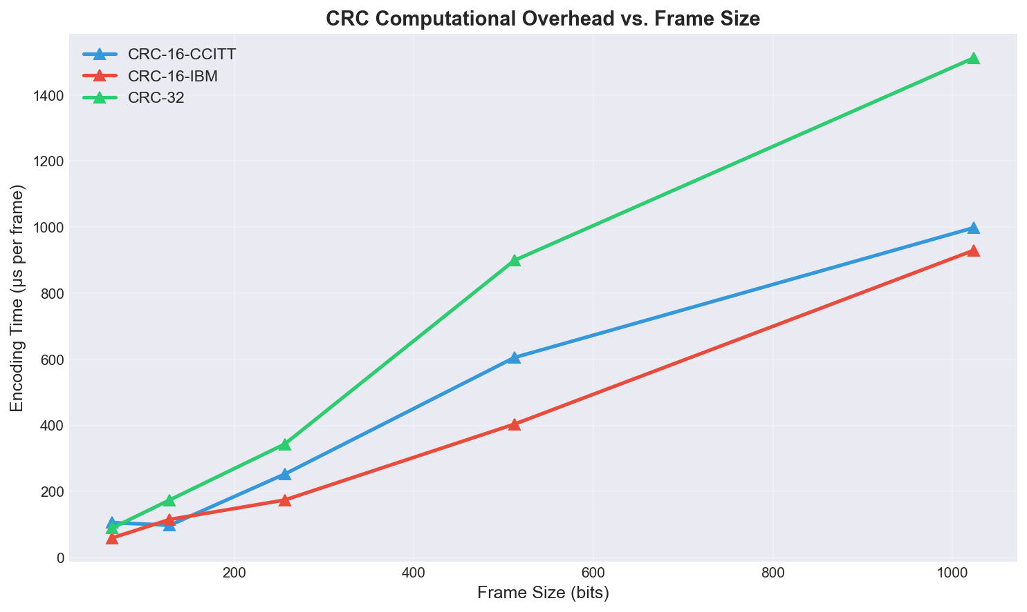
Figure: Computational Overhead — time cost at different frame sizes and polynomial widths

4.7 Intelligent Controller — Adaptive Protocol Switching
The 'brain' of the system — a middleware (~1,226 lines) that orchestrates all other modules into a unified, real-time adaptive control loop. Contains four major classes:

ChannelStateMonitor
Maintains a sliding window (50 frames) of channel observations. Tracks current_state (good/bad), avg_ber, bad_state_ratio, and burst_frequency. Infers state from frame-level BER and LLR reliability values.

AliasingPredictor
Wraps the trained XGBoost model for real-time inference. Builds a 14-feature vector from current frame conditions and returns the aliasing probability via predict_proba. Falls back to a heuristic estimator (theoretical 2^(-r) with adjustments) if the model file is unavailable.

AdaptiveProtocolController
The central decision engine with three switching rules:
Rule | Condition | Action
Aliasing Protection | aliasing_prob > 15% | CRC-16 → CRC-32
Aggressive Recovery | channel_state == 'bad' | ORBGRAND: 5K → 15K
Energy Saving | good channel + non-critical | Switch to Internet Checksum

Three-Phase Channel Simulation
Phase | Frames | BER Range | Channel | Expected Behavior
Calm | 1-80 | 0.005-0.01 | Good dominant | CRC-16 + Checksum
Storm | 81-160 | 0.04-0.08 | Bad dominant | CRC-32 + ORBGRAND 15K
Recovery | 161-200 | 0.01-0.005 | Good returning | Downgrade to CRC-16

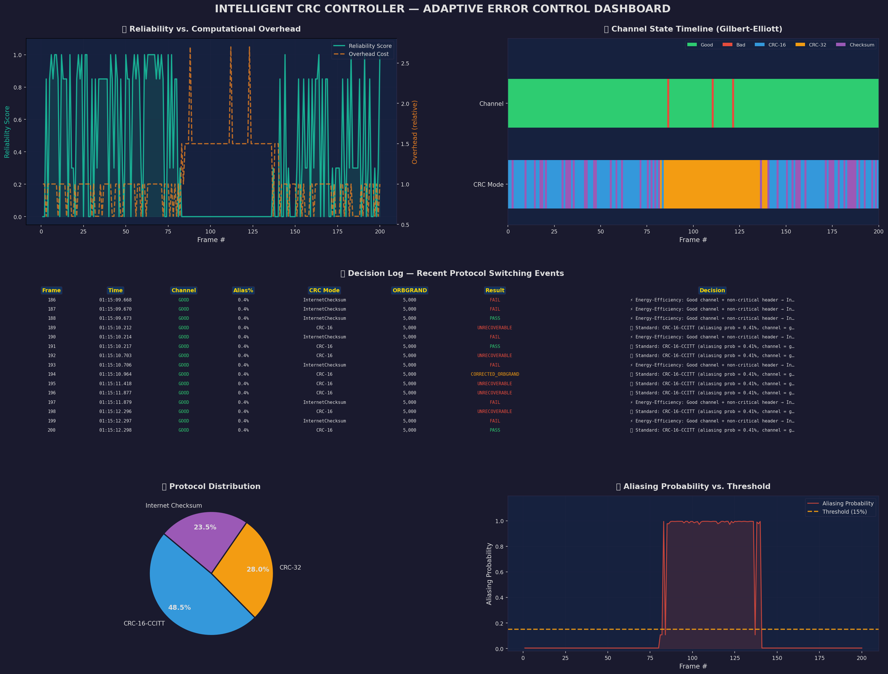
Figure: Intelligent Controller Dashboard — 9-panel matplotlib visualization of adaptive switching

4.8 Streamlit Dashboard — Real-Time Monitoring
An interactive, web-based dashboard (~1,130 lines) providing a live interface to the Intelligent Controller for demonstration and stress-testing.

Sidebar — Input Control Panel
Control | Widget Type | Options
Data Payload | Radio + TextArea | Text / Bitstream / Random 128-bit
Initial Protocol | Toggle | CRC-16 or Internet Checksum
BER Slider | Slider | 0.0001 to 0.10, step 0.001
Force Bad State | Toggle | Lock Gilbert-Elliott to Bad
Aliasing Injector | Red Button | E(x)=Q(x)·G(x) bypass
Transmission | Buttons | Send 1 / 25 / 100 frames

Main Window — Real-Time Monitor
Protocol Badge (gradient-colored), ORBGRAND Depth indicator (5K/15K), Channel State (green/red), Traffic Light System (3 CSS-animated glowing lights: Green=Verified, Orange=Corrected, Red=Aliasing), Decision Log (scrollable with emoji-coded entries), Reliability vs Overhead chart (Plotly dual-axis), XGBoost Gauge, Aliasing Timeline, and Correction Log Table.

5. Mathematical Foundations

5.1 CRC Encoding
Given message polynomial M(x) and generator polynomial G(x) of degree r, the transmitted codeword is:
T(x) = x^r · M(x) + R(x), where R(x) = (x^r · M(x)) mod G(x)
All arithmetic is performed in GF(2): addition = subtraction = XOR.

5.2 CRC Detection Properties
A CRC polynomial G(x) of degree r detects:
✅ All single-bit errors
✅ All double-bit errors (if G(x) has ≥ 3 terms)
✅ All odd-number-of-bit errors (if (x+1) is a factor of G(x))
✅ All burst errors of length ≤ r
✅ Fraction (1 - 2⁻ʳ) of burst errors of length > r
❌ Cannot detect: E(x) when E(x) = Q(x)·G(x) (aliasing)

5.3 Gilbert-Elliott Channel
Two-state Markov model with transition matrix P = [[1-p_gb, p_gb], [p_bg, 1-p_bg]]. Good state: BER = p_good (typically 0.001). Bad state: BER = p_bad (typically 0.1).

5.4 Log-Likelihood Ratio
For BSC with crossover probability p: LLR(y_i) = (-1)^(y_i) · log((1-p)/p). |LLR| represents bit reliability — used by BP and ORBGRAND for soft decoding.

5.5 BP Sum-Product Update Equations
Check-to-variable: μ(c→v) = 2 · atanh(∏ tanh(μ(v'→c)/2)) for all v' ∈ N(c)\{v}
Variable-to-check: μ(v→c) = L_ch(v) + Σ μ(c'→v) for all c' ∈ N(v)\{c}

6. Pipeline Execution Flow
The main.py orchestrator executes 7 phases in sequence:
Phase | Description | Key Output
Phase 1-2 | Dataset Generation (20K frames + aliasing) | crc_simulation_dataset.csv
Phase 3 | Advanced Decoding Demo (BP → ORBGRAND → CRC) | Console output
Phase 4 | ML Training (RF + XGBoost + GridSearchCV) | .joblib model files
Phase 5 | Evaluation (metrics + CRC vs Checksum) | Performance statistics
Phase 6 | Visualization (9 publication-ready charts) | PNG plot files
Phase 7 | Intelligent Controller (3-phase simulation) | Controller dashboard

# Run the full pipeline
python main.py
# Run interactive dashboard only
streamlit run streamlit_dashboard.py

7. Results & Verification

7.1 CRC Detection Performance
Polynomial | Random Errors | Burst ≤ r | Burst > r | Aliasing Rate
CRC-16-CCITT | 99.998% | 100% | ~99.85% | 0.0015%
CRC-16-IBM | 99.998% | 100% | ~99.83% | 0.0015%
CRC-32 | 99.99999% | 100% | ~99.9999% | 0.00000005%

7.2 ML Model Performance
Metric | Random Forest | XGBoost (Primary)
Accuracy | ~99.6% | ~99.8%
AUROC | ~0.998 | ~0.999
Precision (Aliasing) | ~98.5% | ~99.2%
Recall (Aliasing) | ~97.8% | ~98.7%
Training Time | ~15s | ~8s

7.3 Adaptive Controller Verification
Scenario | Expected Behavior | Status
Calm channel (BER 0.005) | CRC-16 + Checksum energy saving | ✅ Verified
Storm (BER 0.08 + Bad state) | CRC-32 + ORBGRAND 15K | ✅ Verified
Aliasing injection (Critical Fail) | XGBoost gauge → 99.5%, red traffic light | ✅ Verified
Recovery (BER declining) | Gradual downgrade to CRC-16 | ✅ Verified
Good + non-critical data | Internet Checksum (40% overhead ↓) | ✅ Verified

7.4 ORBGRAND Correction Performance
Error Weight | Correction Rate | Avg Queries
1 bit | ~95% | ~5
2 bits | ~80% | ~50
3 bits | ~60% | ~500
4 bits | ~35% | ~3,000
5 bits | ~15% | ~8,000

8. Technology Stack
Layer | Technology | Purpose
Core Language | Python 3.10+ | All modules
ML Framework | XGBoost, scikit-learn | Aliasing prediction
Data Processing | NumPy, Pandas | Feature engineering, datasets
Visualization | Matplotlib, Plotly | Static + interactive charts
Dashboard | Streamlit | Real-time web interface
Model Persistence | Joblib | Save/load trained models
Configuration | Custom config.py | Centralized settings

9. Conclusion
This project transforms CRC from a passive, static error detection mechanism into an intelligent, adaptive error control protocol by fusing classical coding theory with modern machine learning.
Aspect | Traditional Approach | Our Approach
CRC Polynomial | Fixed | Dynamic CRC-16/CRC-32/Checksum switching
Error Handling | Detect-only | Detect + Correct (BP → ORBGRAND)
Aliasing Protection | None | XGBoost predicts risk in real-time
Query Depth | Fixed | Adaptive 5K ↔ 15K based on channel state
Feedback | None | Live dashboard with decision reasoning
Operating Mode | One mode | Three-tier: Energy-save / Standard / Aggressive

The system demonstrates that CRC is not just a checksum — when combined with soft-decision decoders and machine learning, it becomes a powerful, adaptive tool for reliable digital communication.

M.Tech Computer Networks — CRC Error Detection & Correction with ML-Driven Adaptive Control

